AFRICAN SOLIDARITY CIVIC ORGANISATION NPC (ASCO)
PAIA Manual
BOARD-APPROVED FINAL DOCUMENTATION
FINAL DOCUMENTATION — BOARD APPROVED; EXECUTION / FILING DETAILS TO BE RECORDED
This document records the Board-approved ASCO governance model and policy position. Legal effectiveness, execution, statutory-register updates and filing or registration requirements must be completed by the authorised persons and recorded in the approval register. The Memorandum of Incorporation remains subject to the Companies Act 71 of 2008 and applicable filing requirements.
DOCUMENT CONTROL
Version: 1.0 | Prepared and Board-approved: 10 September 2026 | Resolution reference: To be entered in the approval register | Effective date: To be recorded where applicable | Next review: To be recorded
1. STATUS
This manual is Board-approved on 10 September 2026. The organisation’s privacy and PAIA contact is info@africansolidaritycivic.org; formal Information Officer registration details are maintained in the organisation’s records.
2. RESPONSIBLE BODY
African Solidarity Civic Organisation NPC, 49 Rif Road, Manor Gardens, Durban, KwaZulu-Natal, 4001, South Africa. Information Officer contact: info@africansolidaritycivic.org; formal designation details are maintained in the organisation’s records.
3. RECORD CATEGORIES
Corporate records; governance records; policies; financial records; donor and grant records; programme records; employment and volunteer records; membership records; personal information records; contracts and correspondence, subject to lawful restrictions.
4. AUTOMATICALLY AVAILABLE INFORMATION
Public website content, current public governance documents, approved public policies and reports published in the document library.
5. REQUEST PROCESS
Requests must be submitted through the designated access email or address using the prescribed PAIA process. Applicable fees, identification, response periods, refusal grounds and appeal/remedy routes must be stated in the final approved manual.
6. POPIA
Personal-information requests and complaints are handled under POPIA and applicable Information Regulator requirements.

Place of approval / execution: 49 Rif Road, Manor Gardens, Durban, KwaZulu-Natal, 4001, South Africa
BOARD APPROVAL SIGNATURES
The following signatures are copied from the signed ASCO documents supplied for this purpose. They record Board approval/acknowledgement in the stated capacities; statutory effectiveness, filing and authority remain subject to the applicable approval and filing process.
CHAIRPERSON / FOUNDER  Ms Busisiwe Makhosi Shandu    Date: 6 September 2026  Signature copied from supplied signed document | DIRECTOR: ICT AND COMMUNICATIONS  Mr Thapelo Nelson Maqalika  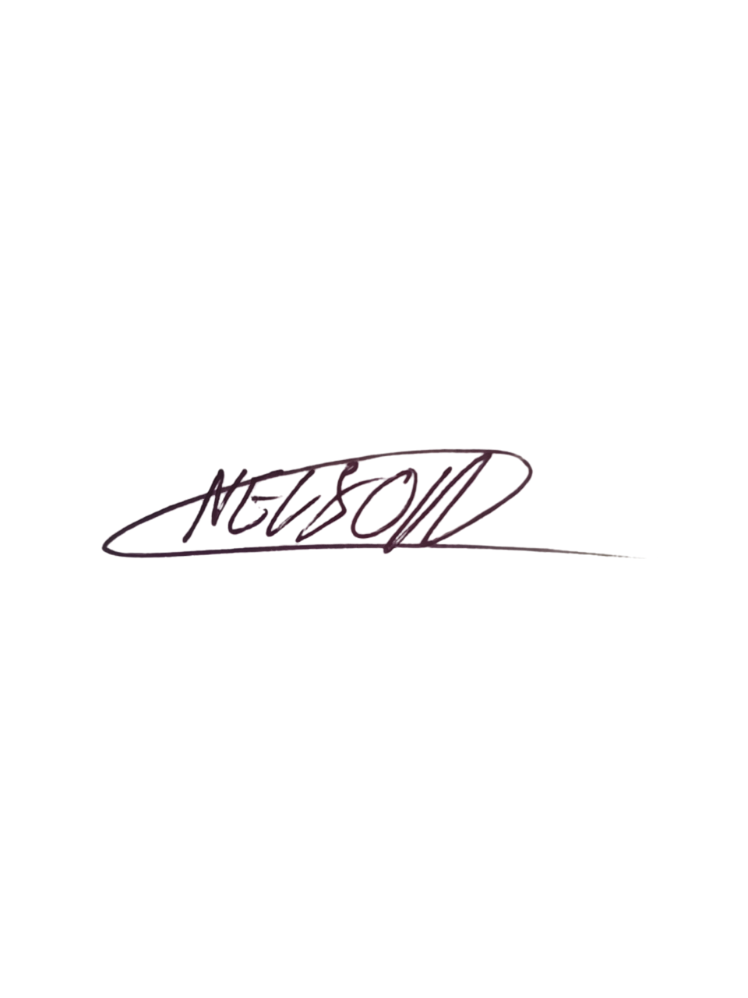  Date: 6 September 2026  Signature copied from supplied signed document
EXECUTIVE DIRECTOR  Mr Bhekisisa Shandu  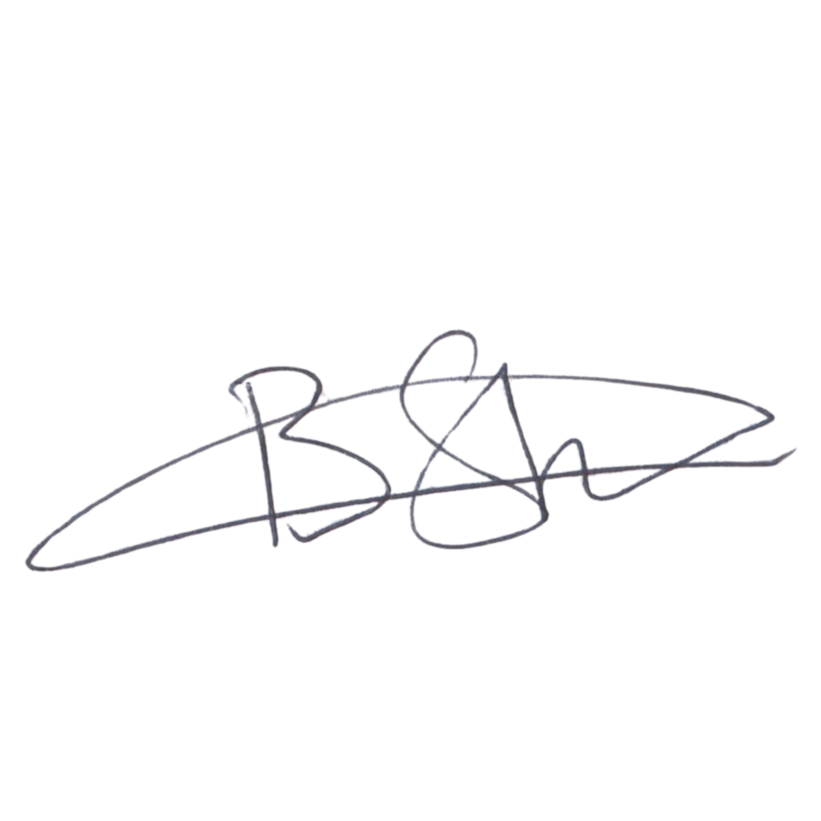  Date: 6 September 2026  Signature copied from supplied signed document | DIRECTOR: PEOPLE AND CULTURE / FINANCE AND PROCUREMENT  Mr Khulekani Gumede  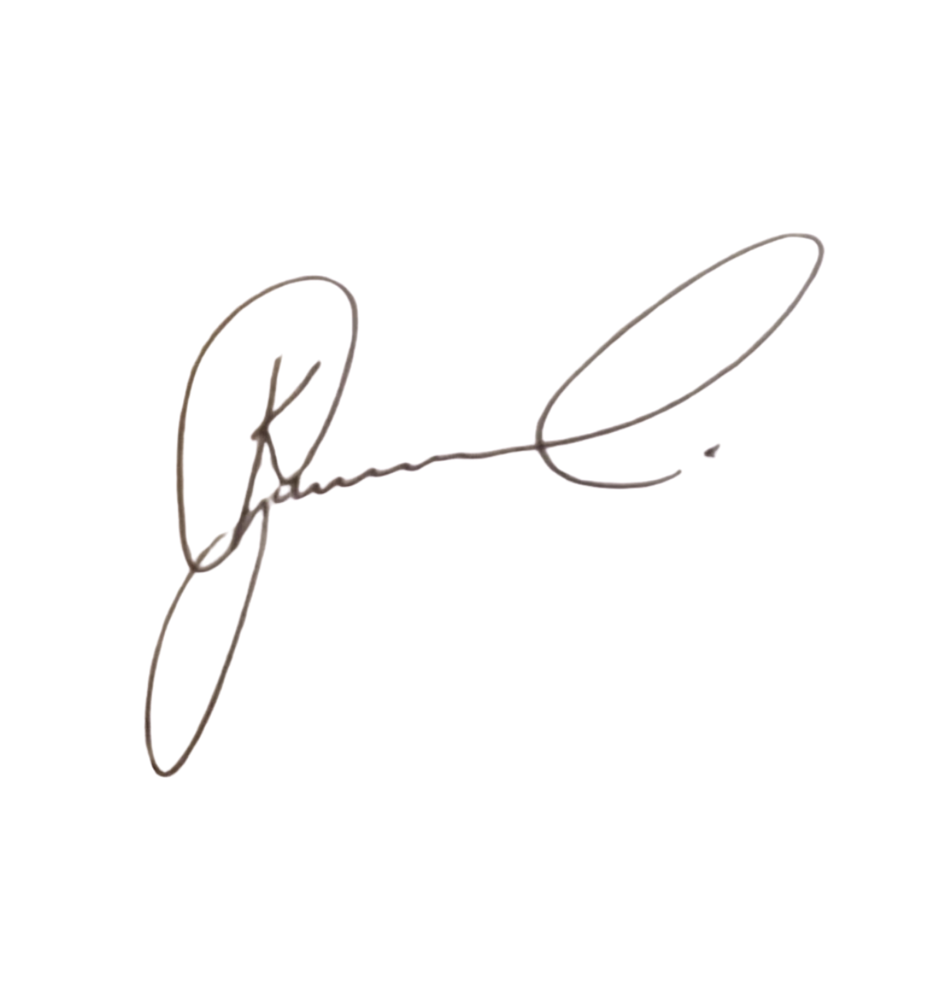  Date: 6 September 2026  Signature copied from supplied signed document

